**Name -Monika Gariya**

**Email-** [**monikagariya2023@gmail.com**](mailto:monikagariya2023@gmail.com)

**Data Engineering Batch 1**

**Date – 18-01-2024**

**Topic – RDBMS, Data WareHouse, OLAP And OLTP, MySQL**

**RDBMS -** A relational database management system (RDBMS) is a program used to create, update, and manage relational databases.

Example - MySQL, PostgreSQL, MariaDB, Microsoft SQL Server, and Oracle Database.

**DATA WAREHOUSE**

Data Warehousing is a process of collecting, storing and managing large volume of data from different sources to support business intelligence and reporting activities.

Data Warehouseis a database used for data reporting and analysis.

The data stored in the warehouse are uploaded from the operational systems (such as marketing, sales etc.)

The data in the data warehouse is stored in the form of **Data marts**

**DATA MARTS**

The data mart is a subsetof the data warehouse that is usually oriented to a specific business.

It is a data storage system that contains information specific to an organization's business unit.

**OLAP (ON-LINE TRANSACTION PROCESSING)**

**On-Line Transaction Processing (OLTP) System** refers to the system that manage transaction-oriented applications. These systems are designed to support on-line transaction and process query quickly on the Internet.

**Example** – ATM (Automated Teller Machine), online booking, ticket and reservation system.

**OLAP (Online Analytical Processing)**

OLAP (online analytical processing) is a computing method that enables users to easily and selectively [extract](https://www.techtarget.com/searchbusinessanalytics/answer/Examining-different-data-access-methods-OLAP-and-data-mining) and [query](https://www.techtarget.com/searchdatamanagement/definition/query) data in order to analyse it from different points of view. OLAP business intelligence queries often aid in trends analysis, financial reporting, sales forecasting, budgeting and other planning purposes.

**Example** - Marketing analysis, Customer and product profitability, Supply and Demand forecasting, Human resources analysis, Resource analysis and capacity planning, Variance analysis

**OLAP ARCHITECTURE**

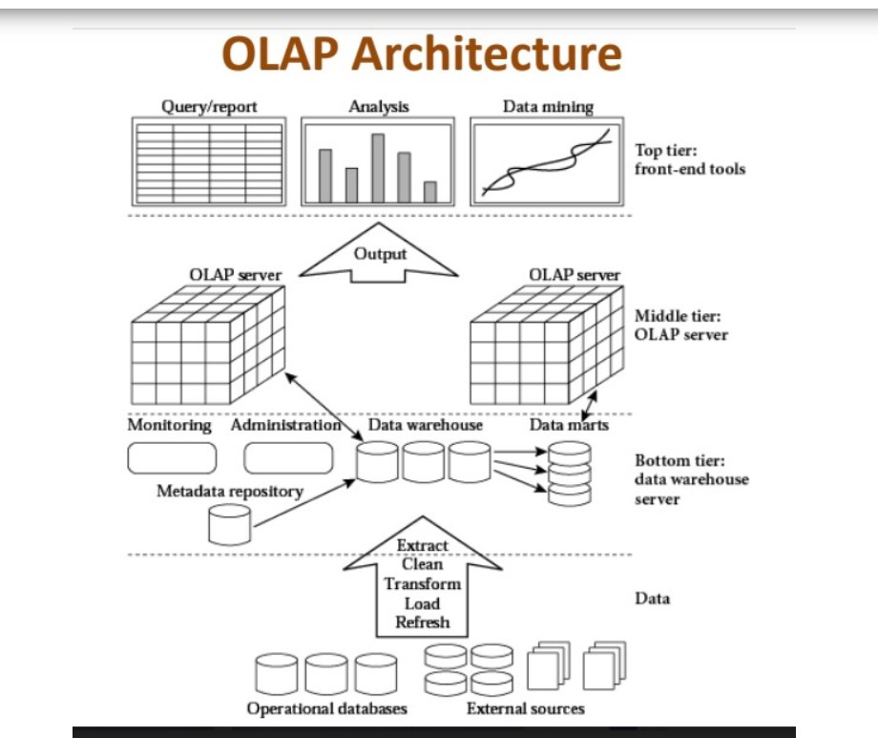

**MySQL**

* MySQL is a relational database management system
* MySQL is open-source
* MySQL is free
* MySQL is ideal for both small and large applications
* MySQL is very fast, reliable, scalable, and easy to use
* MySQL is cross-platform
* MySQL providing multi-user access to a number of databases.

**FEATURES OF MySQL**

**Easy to use** - MySQL is easy to use. We can build and interact with MySQL by using only a few simple SQL statements.

**It is secure** - MySQL consists of a solid data security layer that protects sensitive data from intruders. Also, passwords are encrypted in MySQL.

**Free to download**-MySQL is free to use so that we can download it from MySQL official website without any cost.

**Speed**-MySQL is considered one of the very fast database languages, backed by a large number of the benchmark test.